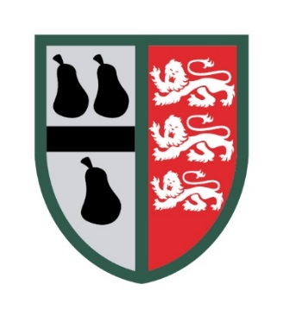
Worcestershire & Herefordshire RFU AGM
Wednesday 21st May 2025 7pm
Droitwich RFC

Meeting Agenda
- Persons Present
- Apologies
- To consider and approve (with or without amendment) the minutes of the previous AGM held on Tuesday 28th May 2024
- Matters Arising from those minutes.
- To receive and approve a report from the committee on the affairs of the Union since the previous AGM.
- To consider any other business which due notice shall have been given under rule 8.5
- To elect Officers for season 2025-26
7. AOB
8. Date of Next AGM: Wednesday 20th May 2026, venue TBC.

