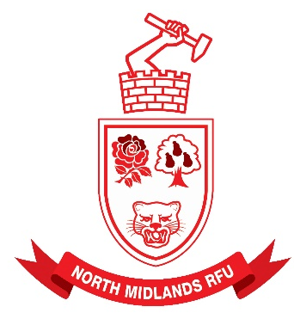

NORTH MIDLANDS RUGBY FOOTBALL UNION LIMITED
WWW.NORTHMIDSRFU.CO.UK

2024 / 2025 Boys Youth Cup Competitions

All North Midlands Clubs with Youth Sections are invited to enter the following competitions.

Under 14’s Cup and Plate
Under 15’s Cup and Plate
Under 16’s Cup and Plate

The ages refer to the players at midnight on 31st August / 1st September 2024

The entry fee for each team will be £20.00

Payment can be made via BACS online at: Account Name: North Midlands RFU Limited Account Number: 31436279 Sort Code: 40–20–27. Please state on the online payment which team and club you are paying for.

This entry form must be completed and returned to Alex Smith at northmidsyouthcups@outlook.com for each team entered.

Club Name:
Fixture Secretary Name:
Fixture Secretary Email Address:
Team (U14/U15/U16):
Team Contact Name:
Team Contact Email Address:

All entries must be completed by 12 noon on Monday 9th September 2024

