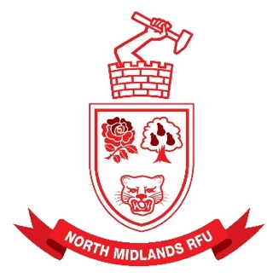
NORTH MIDLANDS RUGBY FOOTBALL UNION LIMITED
WWW.NORTHMIDSRFU.CO.UK

Volunteer Coordinator: John Griffiths
30 Buttons Farm Road, Penn, WV4 5LY
Tel: 01902343420(H) 07736244638(M)
email: nmvolunteerawards@gmail.com

March 2024

North Midlands Volunteer Awards 2024

It is the time of the season when we ask Clubs to nominate People for the North Midlands Volunteer Awards.
There are Six Categories for which any Club Member may Nominate any Volunteer. The Categories are
Long Serving
Young Volunteer
“Senior Club” Volunteer
“Age Grade” Volunteer
“Whole Club” Volunteer
Volunteer Groundsman
From these we, a panel, will select the best in each category and from them the overall
NM Clubman of the Year 2024

The panel will include in our deliberations any Nominees for the Honda Volunteer Awards who do not make their Finals as and how they fit the NM Categories.
The Panel may award other nominees that they consider to be very worthy of recognition without clearly fitting any Category.

Please look round the Volunteers in your Club and Nominate as many as you like. They may be Nominated as a Group if you think that it is the group together that deserves recognition.

Nominations will Close on 30th April 2024 with the Awards being announced and Presented in the Early Part of Season 2024-5

Please send your nominations on the attached form to John Griffiths at nmvolunteerawards@gmail.com

Many Thanks

John Griffiths
NM Volunteer Coordinator

