
NORTH MIDLANDS RUGBY FOOTBALL UNION LIMITED
WWW.NORTHMIDSRFU.CO.UK

Hon Treasurer: Roger Parsons
Cedar Court, Packwood Lane, Lapworth, Solihull, West Midlands, B94 6AU
Tel: +44 (0) 7976 298788
Email: roger.parsons@cedarcourt.net

7th December 2023

All Member Clubs of North Midlands Rugby Football Union Limited

Dear Treasurer,

Annual Accounts 2022/2023 Season

I am sure you are aware of RFU Regulation 5 – Financial and specifically section 5.1.3 that states:

“On or before 31st December each year, each club at Levels 1 to 4 (inclusive) shall send to the RFU’s Chief Financial Officer and every other club send to the Treasurer of their respective Constituent Body, a properly prepared financial statement for the previous season as presented to Club Members at a general meeting……………….”.

I have to report that I have received Club accounts so far from: Ledbury RFC / Bromyard RFC / Kidderminster RFC / Kings Norton / Bromsgrove RFC / Upton on Severn RFC / Bishops Castle RFC and B’Ham & Solihull RFC.

I would therefore urge all other clubs to send me without further delay a copy of your accounts cover the 2022/2023 season.

Regards
Yours sincerely

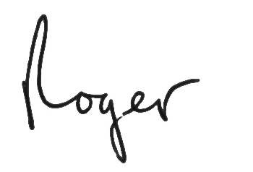

Roger Parsons
Hon Treasurer

