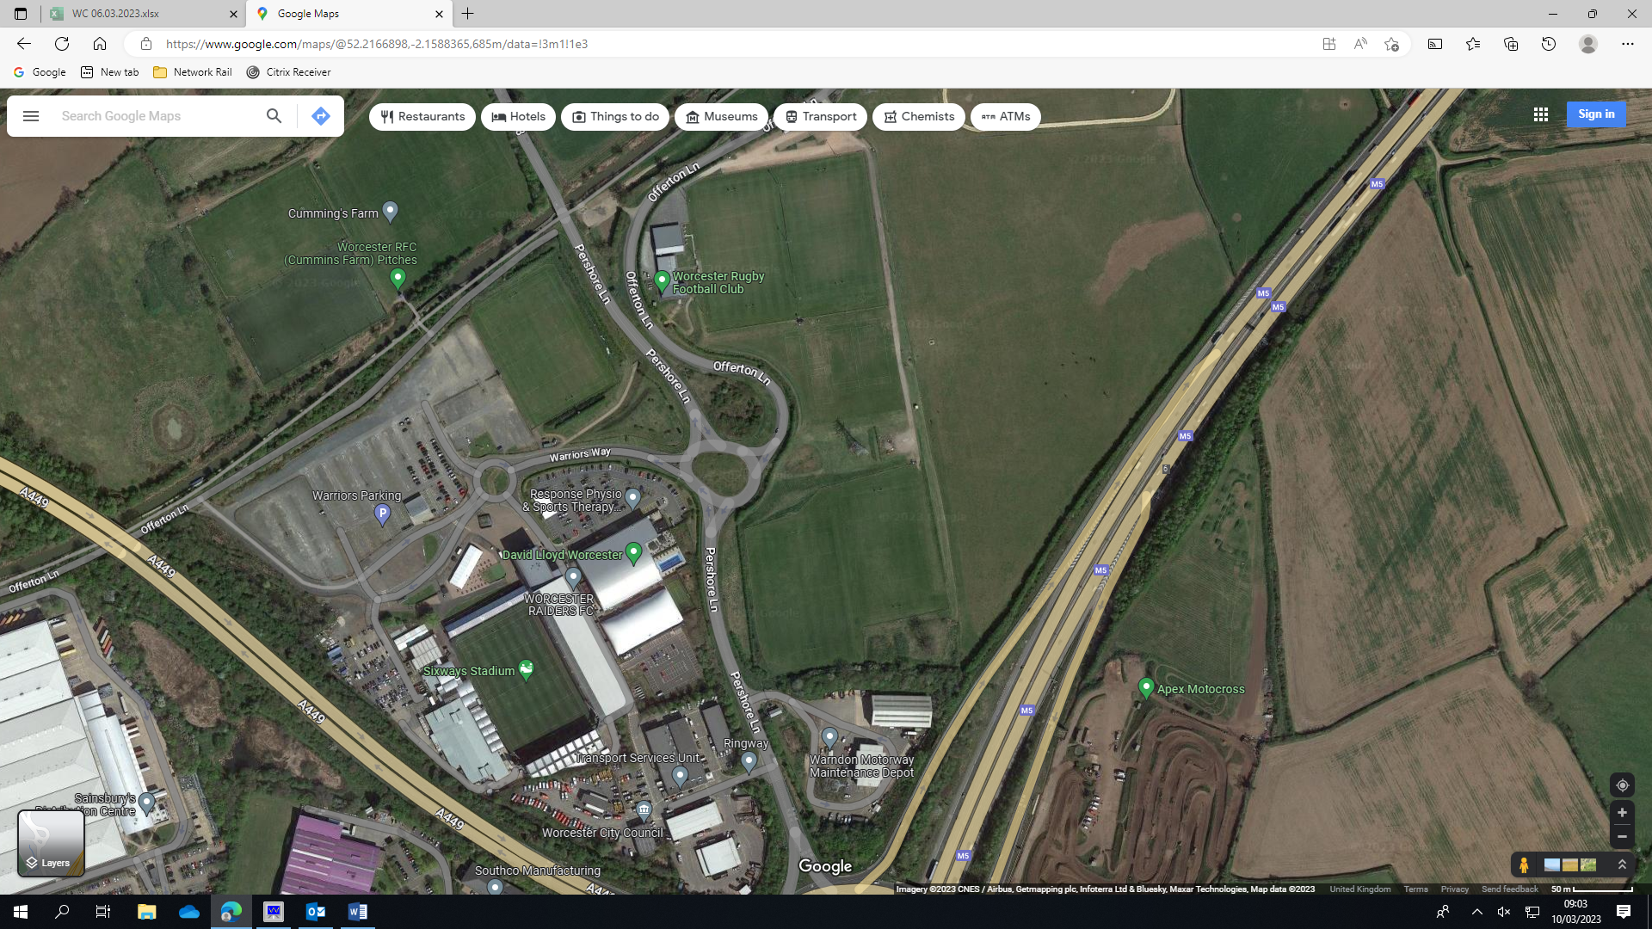
Route Map for All Parking and Entance to North Mids Finals Day
Club Main Gate
NO GENERAL ENTRANCE
NO DROP OFF
Except:
Car Pass [VIP] or Hold a Blue Badge
Emergency services
FOR ALL PARKING FROM DROITWICH
PERSHORE LANE TOWARDS ROUNDABOUT
3RD EXIT ONTO WARRIORS WAY

All other parking
THIS IS KNOWN AS
CAR PARK A
No on-site parking with out
Car pass or blue badge

FOOTPATH TO ENTRANCE

GENERAL ENTRANCE
VIA underpass from/to carpark
Cash or Card taken for entrance fee
[£5pp, u16 free]

All Coach Parking
Drive in to drive out
NO DROP OFF AT CLUB ALLOWED

FOR ALL PARKING FROM
M5, JUNCTION 6
ROUNDABOUT EXIT 5 TOWARDS DROITWICH
PERSHORE LANE
1ST EXIT INTO WARRIORS WAY

NOTE
ONLY FOOD AND DRINK PURCHASED ON SITE TO BE CONSUMED
BE RESPECTFUL TO ALL VOLUOTEERS, THE MEASURES ARE IN PLACE FOR YOUR’S AND EVERYBODIES SAFETY
BEST OF LUCK FROM ALL AT WORCESTER RUGBY FOOTBALL CLUB

